ix 1Jack et al.- High-throughput plant defense analysis

**A high-throughput method of analyzing multiple plant defensive compounds in minimized sample mass1**

Chandra N. Jack2,6,§, Shawna L. Rowe3,§, Stephanie S. Porter4, Maren L. Friesen2,5

2 Washington State University, Department of Plant Pathology, Pullman, WA, 99164

3 Michigan State University, Department of Plant Biology, East Lansing, MI 48824

4 Washington State University, School of Biological Sciences, Vancouver, WA

5 Washington State University, Department of Crop and Soil Sciences, Pullman, WA

§Co-first authors

Email Addresses: CNJ: [chandra.jack@gmail.com](mailto:chandra.jack@gmail.com)

SLR: [roweshaw@gmail.com](mailto:roweshaw@gmail.com)

SSP: [stephanie.porter@wsu.edu](mailto:stephanie.porter@wsu.edu)

MLF: [m.friesen@wsu.edu](mailto:m.friesen@wsu.edu)

Number of words: 2752

1 Manuscript received _______; revision accepted _______.

6 Author for correspondence: [chandra.jack@gmail.com](mailto:chandra.jack@gmail.com)

**ABSTRACT**

*Premise of the study:* Current methods for quantifying herbivore-caused alterations in plant biochemistry are expensive, time-consuming, and require large tissue amounts. We present a cost-effective, high-throughput protocol to quantify multiple biochemical responses from small plant tissue samples using spectrophotometric techniques.

*Methods and Results:* Using *Solanum lycopersicum* and *Medicago polymorpha* leaves pre- and post-herbivory, we demonstrate that our protocol quantifies common plant defense responses: peroxidase production, polyphenol oxidase production, reactive oxygen species production, total protein production, and proteinase inhibition activity.

*Conclusions:* Current protocols can require 500 mg of tissue, but our assays detect defense activity in under 10 mg. Our protocol takes two people approximately 6 hours to run any of the assays on 300 samples in triplicate, or all of the assays on 20 samples. Our protocol enables researchers to plan more complex experiments that compare local versus systemic plant responses, quantify environmental and genetic variation, and measure population level variation.

**Key words:** Microplate; Plant Defense Response; Peroxidase; Polyphenol oxidase; Protease Inhibitors; Protein Quantification

**INTRODUCTION**

The ability to quantify plant molecular responses to herbivory over time and compare variation within populations is useful in many research areas from ecology and evolutionary biology to applied agricultural research. Unfortunately, current methods are expensive, time consuming, and typically require large tissue masses. However, like many attempts to assay molecular responses, research is limited by the rigorous nature of quantifying subtle physiological changes. Previously developed assays are thus effective but unusable by many researchers due to financial constraints - (i.e. lack of access to spectrophotometers or large quantities of reagents) or the need to conduct a given assay on a large set of samples. These constraints have been recognized and addressed in some instances, such as protein quantification (Olson and Markwell 2007). With the development and widespread use of microplate readers, some assays such as protease inhibition and protein quantification, have been scaled and optimized for smaller reaction volumes and larger sample numbers resulting in better replication (Pande and Murthy 1994; Olson and Markwell 2007).

One of the earliest biochemical responses to herbivory is the production of reactive oxygen species (ROS) such as superoxide (O-), hydrogen peroxide (H2O2), and hydroxyl radicals (HO-) after depolarization of the plasma membrane due to leaf damage (Maffei et al 2012; War et al 2012; Zebelo & Maffei 2015). Both chemical treatments and mechanical wounding can elicit ROS production (Maffei et al 2007). H2O2 production is both used as a local signal to induce the hypersensitive response when plants are subjected to mechanical damage as well as a systemic signal for the induction of additional defense responses (Orozco-Cárdenas & Ryan 1999). The presence and activity of ROS additionally results in the production of a group of enzymes, peroxidases (POD), that are upregulated to perform a diverse set of physiological processes such as metabolism of ROS, restructuring of cellular walls, cross-linking of complex polymers, and other critical functions (War et al 2012). Increases in POD activity also decrease the nutritional quality of leaf tissue, which significantly reduces the growth and development of insect larvae. Finally, the presence of plant PODs in insect guts may also be toxic to insects.

Two additional compounds that are produced in response to herbivory are polyphenol oxidase (PPO) and proteinase inhibitors (PI) (Mithöfer & Boland 2012; War et al 2012). PPO is upregulated directly by the presence of herbivore-associated signaling compounds such as methyl-jasmonate (Koussevitzky et al 2004). PPO breaks down diphenolic compounds to produce more reactive phenolic compounds that have anti-insect activity once consumed (War et al 2012). Protease inhibitors (PI) are small molecules that prevent proteolytic activity. In response to herbivores, plants will produce PIs to inhibit protein catabolism in insect guts which can halt the degradation of proteins that may serve as precursors used for various physiological processes (Mithöfer & Boland 2012).

Assaying multiple responses on individual samples is critical for understanding host responses since many defense responses are interrelated. A prime example of this is the direct relationship between reactive oxygen species production and the induction of peroxidases. Peroxidases such as glutathione peroxidase reduce H2O2 and are induced in response to high levels of H2O2 and catalyze the oxidation of other molecules (Quan et al. 2008); measuring both peroxide and peroxidase in the same sample thus gives additional insight into this cellular process.

Additionally, reducing the total amount of tissue required for an expanded array of assays enables researchers to perform both small molecule and enzymatic assays during a given investigation by allowing two separate extraction buffers to be used resulting in smaller amounts of tissues being assayed in more ways. This allows complex responses across large numbers of individuals to be analyzed within a single experiment. Early methods of protein quantification such as the Bradford method and the Lowry method were dependent on the use of a spectrophotometer and thus large sample volumes (Bradford 1976). Currently, assaying for the production of small molecules requires severe buffering conditions that both inhibit and degrade proteins present in suspended tissue samples due to the presence of compounds such as trichloroacetic acid, which causes protein precipitation (Rajalingam et al. 2009) preventing the use of a single buffer. Additionally, as with protein-based assays, the large sample masses required as a result of large reaction volumes for current spectrophotometric techniques limits the total number of technical replications and assays that can be performed on a given sample.

Since the onset of the next generation sequencing revolution, many studies use genomic data as evidence of variation. Although this has proven to be a highly useful tool in many studies, it is important to assess functional variation as well. Studies have indicated that transcript abundance doesn’t necessarily match functional activity in a tissue samples (Greenbaum et al. 2003). This finding and others like it are important to consider when assessing functional diversity in physical populations of organisms.

These problems ultimately result in either A) researchers assaying single physiological changes induced by herbivory as a metric for general herbivory responses or B) resorting to various -omics techniques that are oft expensive and ill-suited to provide detailed information regarding specific physiological responses. Paired together, assaying both small molecule production and enzyme production would allow for a more holistic assessment of herbivory-associated plant immunity responses while sidestepping the many issues brought on by employing -omics techniques as an alternative (xxxx).

Here, we present a cost-effective method to assay multiple molecular responses in small sample masses (Appendix 1). The assays include total protein content, peroxidase, polyphenol oxidase, H2O2, and trypsin-like protease inhibitors. Many defense responses can be assayed individually, but require diverse tissue extraction methods that are mutually exclusive. For our purposes, we selected induced responses that were both diverse and able to be assayed from a common sample extract. We tested our method on leaves taken from *Solanum lycopersicum* pre- and post-herbivory to show that our assays can quantify differential plant responses. *S. lycopersicum* is often used to test biochemical defense responses, which allows us to compare our results to published studies. After validating our assays using *S. lycopersicum,* we tested our protocol using *Medicago polymorpha*, a leguminous plant whose biochemical responses to herbivory have not been quantified. With trifoliate leaves that may weigh less than 50 mg, *M. polymorpha* is representative of a “non-model” plant. This protocol paves the way toward more comprehensively assaying plant biochemical responses to herbivory in non-model plants and allows for greater sample capacity, which would allow for improved statistics, time course experiments, and more complex experimental designs.

**METHODS AND RESULTS**

***Tissue preparation—*** To compare our protocol to current spectrophotometer protocols, we used tomato (*Solanum lycopersicum,* ecotype M82*)*, a model plant often used for testing defense responses, and the non-model plant *Medicago polymorpha*. Tomatoseeds were scarified with 600 grit sandpaper, imbibed in dH2O for three days at 4°C in the dark to stratify, then placed in a dark cabinet overnight. Germinated seedlings were grown for three weeks in a grow room before inducing defensive responses. Burr medic (*Medicago polymorpha*) seeds (Appendix 2) were scarified as described above and planted into 158-mL pots filled with Sungro Sunshine Mix #1 (SunGro® Horticulture, Michigan, USA). Plants were inoculated a week after planting with a rhizobium strain mixture of 107 cells of equal parts *Ensifer medicae* strain WSM419 and *E*. *meliloti* strain 1021 to prevent nitrogen starvation and to mimic natural conditions.

To ensure that our protocol could adequately detect plant defense responses both pre- and post-herbivory, we allowed soybean loopers (*Chrysodeixis includens*) to feed on leaves and also manually induced plant responses using caterpillar regurgitant to account for variable insect feeding patterns. Regurgitant was generated by compressing stomachs with forceps post feeding on corresponding host plants. Leaves were manually wounded with scissors dipped in regurgitant. Leaf samples were taken from each plant at 0 and 24 hours and flash frozen in liquid nitrogen for storage at -80°C until processing.

**Assays—** One challenge of attempting to assay multiple enzymes and small molecules from a single sample is finding an appropriate extraction buffer that will preserve the integrity of the metabolites while not creating conditions inhibitory for other assays.We were able to utilize two extraction buffers: a trichloroacetic acid (TCA) buffer and a protein extraction (PE) buffer. The TCA buffer provides the appropriate conditions for assaying the production of hydrogen peroxide (Junglee et al. 2014). The PE buffer was designed to provide the best crude extraction without the presence of interfering compounds. Phenylmethane sulfonyl fluoride (PMSF), the serine protease inhibitor commonly present in protein extraction buffers (Grimplet et al. 2009), was removed due to the need to assay the production of trypsin-like protease inhibitors. Β-mercaptoethanol, also a common protein buffer ingredient (Grimplet et al. 2009) used as a reducing agent to ensure analysis of strictly monomeric proteins, was removed due to interference with the Thermo ScientificPierceTM BCA Protein Assay Kit. Previous studies, specifically ones from which we modified original assays (Cavalcanti et al. 2004; Goud and Kachole 2012) used extraction buffers lacking protease inhibitors and/or reducing agents with no significant change to final results. Our PE buffer thus results in a crude extract that provides predictable results when published assays were replicated for validation purposes (Table 2).

Frozen leaf tissue from each plant was placed into two microcentrifuge tubes and weighed. The tubes were homogenized for 15 minutes at 300 rpm in a tissuelyser (QIAGEN TissueLyser II, QIAGEN, Maryland, USA)**.** The tube holders were made of teflon and stored at -80°C. All samples and holders were also dipped in liquid N2 before homogenizing.One tube received 1mL of the 0.1% TCA buffer, while the other received 1 ml of the PE buffer (1mM EDTA, 88mM Trizma Base, 10% glycerol). Tubes were centrifuged at 4°C for 10 minutes at 15000 rpm in an accuSpin Micro 17 centrifuge (Thermo Fisher Scientific, Waltham, USA) and the supernatant pipetted into clean tubes. The PE extract samples were then diluted to 1/10X. All absorbance values were run on a SpectraMax M2 combination spectrophotometer and microplate reader and standardized for fresh weight (FW). A detailed description of our protocols can be found in Appendix 1.

*Protein Quantification*

Total protein content was measured using the Thermo ScientificPierceTM BCA Protein Assay Kit (Product number: 23337, Thermo Fisher Scientific) according to manufacturer instructions for microplate samples and was included to test the efficacy of our protein extraction buffer.

*Peroxidase (POD) Activity*

POD activity was measured in triplicate for each sample and also included a tissue specific control. Wells of the microplate designated as treatment wells received 143 µL of peroxidase reaction buffer (100 mM sodium phosphate buffer (pH 6.5) containing 5 mM guaiacol). Control wells received 143 µL of 100 mM sodium phosphate buffer (ph 6.5). 25 µL of supernatant (enzyme source) was added to each well.  We then added 32 µL of 5 mM H2O2(final concentration 0.8 mM) to start the reaction. Plates were incubated in the dark for 15 minutes at room temperature before reading absorbance values at 470 nm.

*Polyphenol oxidase (PPO) Activity*

PPO activity was also measured in triplicate per sample (biological replicate) with a tissue specific control. Sample wells received 115 µL of 100 mM sodium phosphate buffer (pH 6.8) and 60 µL of 50 mM pyrocatechol. Control wells received 175 µL of 100 mM sodium phosphate buffer (pH 6.8). 25 µL of supernatant (enzyme source) was added to all wells. Samples were incubated for 5 minutes before reading absorbance values at 420 nm.

*Proteinase inhibition (PI) Activity*

Proteinase inhibition activity was quantified using an adapted method from (Orians et al. 2000) where activity is represented by the inhibition of trypsin. This assay requires the preparation of two reaction buffers per sample. Reaction buffer 1 was prepared in tubes with 133.3 µL of Trizma Base buffer, 83.3 µL of 2% azocasein dissolved in Trizma Base buffer, and 33.3 uL of 0.001 M HCl solution containing 200 ng of trypsin. Reaction buffer 2 was the same as reaction buffer 1, but additional Trizma base was substituted for the trypsin solution. 100 µL of the sample extract was added to each tube. These serve as the sample measurement tube and the sample control tube. Reaction buffers 1 and 2 were used for positive and negative assay controls, respectively. The assay controls received 100 µL of Trizma base instead of enzyme source. All tubes were incubated at 30°C for 25 minutes. Post-incubation, 133 µL of 100% w/v TCA was added and tubes were centrifuged at 8000 rpm for 10 minutes. After centrifugation, 100 µL of the supernatant were added to wells of a microplate that contained 100 µL of 1M NaOH and absorbance was measured at 450 nm. As with the other assays, samples were run in triplicate.

*Hydrogen peroxide (H2O2) Quantification*

The hydrogen peroxide quantification assay (H2O2) was implemented with few modifications. The primary change was to the measurement wavelength. As measured in Junglee et al. (2014), the triiodide produced as a result of the reaction mechanism has optimal absorbance at 285 nm with significant differences able to be determined at wavelengths up to 410 nm. We selected 390 nm due to previously published H2O2 assays (Velikova et al. 2000; Junglee et al. 2014), and the results of our spectral scan that indicated no significant differences in absorbance values at 390 nm relative to absorbance at 350 nm (t(5) = -1.608, p = 0.169) and the fact that 285 nm is cleanly in the ultraviolet range which requires special plates to avoid issues of interference from the standard polymers used in 96-well plates. Sample aliquots were taken from the 0.1% TCA buffer extraction. Sample wells received 100 µL of 1M potassium iodide (KI), 50 µL of 10mM potassium phosphate buffer (pH 6.5), and 50 µL of sample aliquot. Control wells received 100 uL of dH2O, 50 µL of 10mM potassium phosphate buffer (pH 6.5), and 50 µL of sample aliquot to account for tissue coloration. Samples were incubated in the dark for 20 minutes at room temperature. A standard curve was prepared by preparing wells with 100 µL of 1M potassium iodide (KI), 50 µL of 10mM potassium phosphate buffer (pH 6.5), and 50 µL of 0.1% TCA then seeding with known amounts (5-20 nmoles) of H2O2. Absorbance was measured at 390 nm and values were compared to the standard curve for quantification in nanomoles.

**Protocol Validation—** The success of our protocol hinges on three points that we address through different validation methods. First, we validated that our assay is able to accurately quantify the same amount of enzyme activity compared to assays run using a spectrophotometer. We focused on POD and PPO, the two enzymes assayed given these were the most modified protocols. Implementation of published protocols (Orians et al. 2000; War et al. 2011) on *S. lycopersicum* provided us with a point of reference for comparison of our modified methods. By first establishing an expected response to a given treatment we are able to determine if the measured microplate response is sufficiently similar and reproducible. Both assays underwent similar modifications during the scaling process. Previous protocols required between 0.025 mL to 0.100 mL of 1X crude extract to be assayed in a final volume of between 2.5 mL and 3.1 mL of solution (Cavalcanti et al. 2004; Goud and Kachole 2012). When scaling our total assay volumes down to fit the requirements of a standard 96-well microplate the volumes were reduced ~100 fold.

For each assay we generated standard curves from enzymes obtained from Worthington Biochemical Corporation (New Jersey, USA). Horseradish peroxidase with an activity of 220 U/mg dry mass was diluted to a stock concentration of of 100 mU/mL in PE buffer. Standard curves were used to verify that the protocol was detecting analyte quantities within the detection limits of the machines used for absorbance measurements (Fig. 1). Serial dilutions were performed to get the concentration values as follows: 100 mU/mL, 50 mU/mL, 25 mU/mL, 10 mU/mL, 5 mU/mL, 2.5 mU/mL, 1.25 mU/mL, 0.625 mU/mL, and 0 mU/mL.

Mushroom polyphenol oxidase with an activity of 630 U/mg dry mass was diluted to a stock concentration of 100 U/mL in PE buffer. Serial dilutions were performed to get the concentration values as follows: 1000 U/mL, 500 U/mL, 250 U/mL, 125 U/mL, 62.5 U/mL, 31.625 U/mL, 15.625 U/mL, 7.81 U/ml, 3.91 U/mL, 1.95 U/mL, 0.977 U/mL. Absorbance values were measured using the SpectraMax M2 and the r2 values are similar for both standard curves (Fig 1). This suggests that both machines are able to accurately predict concentrations given an absorbance due to the high r2 values.

Given the large quantities of tissue that are required for spectrophotometric-based assays, researchers are often forced to pool tissue samples from different plants. Our microplate protocols require much smaller quantities of plant tissue, allowing us to measure each plant individually. Current practice for many of these assays is to pool tissue samples from multiple plants. We show that there is significant variation in expression both pre- and post-herbivory between the five tomato plants of the same ecotype used in all five assays (Appendix 3 and Table 1). Table 1 shows the results of an ANOVA where we compare Absorbance values based on plant sample pre- and post- herbivory and show that there is significant variation between plants of the same ecotype that were grown in the same environment. This variation highlights the strength of our assay, which does not require plant tissue to be pooled This is important because it indicates that our readings are more reproducible than alternative methods (Table 2). Pooling tissue samples, such as what is required to get adequate tissue masses for spectrophotometric assays, increases variability due to the sample pool containing multiple individual plant responses and makes a strong argument for assaying individual plants (Zhang and Gant 2005). The difference in absorbance means between the microplate method and the spectrophotometric method are not of concern since differences can be explained as a consequence of using different detection methods. However, researchers are limited in what they can measure using spectrophotometers if their study system does not develop large or many leaves. We serially diluted tomato tissue to measure the lower limits of detection for our POD and PPO microplate assays and found that we were able to detect expression in as little as 3.8 mg of tissue. This was determined by doing a series of dilutions on a tissue sample to determine the linear range of the microplate assay (Fig. 2). Then, we ran all of our assays on trifoliate leaves (ranging in mass from 12 mg to 56 mg) collected from *M. polymorpha* as proof of concept that we could detect expression in actual small leaf tissue samples (Appendix 4).

**CONCLUSIONS**

The measurement of plant biochemical variation in response to insect herbivory previously faced substantial limitations that have hindered the progress of the field. In particular, current practice in many labs is to use a single ecotype to measure differences between experimental treatments and to pool tissue from multiple leaves and individuals to obtain sufficient sample mass (War et al. 2011; Rajendran et al. 2014; Ferrieri et al. 2015). However, this approach has precluded the study of variation within and between individuals, which is what is relevant for real-world interactions (Whitham 1983; Winn 1996; Bolnick et al. 2011). In contrast to previous techniques (Orians et al. 2000; War et al. 2011; Junglee et al. 2014), our protocol offers the ability to implement multiple assays on a large sample set by consolidating sample preparation buffers and running all assays on a microplate reader. This not only dramatically reduces the amount of tissue needed for a given assay, but also reduces the total time required to perform a given assay set.

Using our high-throughput protocols, researchers can now compare variation both within and between individuals, genotypes, and populations. Genetic and evolutionary biology studies often focus on variation between genotypes [e.g. (Fitzpatrick et al. 2015; Kerwin et al. 2015)], which requires higher levels of experimental replication afforded by our method. Understanding the genetic variation associated with plant biochemical responses is critical both for understanding how coevolution has shaped these interactions as well as for the success of molecular plant breeding for enhancing these interactions in agronomic settings. Importantly, our protocol also enables paired measurements of multiple defense responses on the same tissue. This has several advantages over testing pools of tissue or defense responses on separate tissues–notably, we find high inter-individual variation in biochemical responses within a single genotype of *Solanum lycopersicum*, underscoring how critical it is to perform paired assays. Furthermore, measuring the production of multiple metabolites/enzymes within a single sample will enable researchers to quantify tradeoffs in phytochemical production at the level of individual leaves, the scale at which insects interact with their plant hosts. Our protocol also enables researchers to compare systemic versus localized defense responses within the same plant, since multiple leaves can be assayed in parallel. Moreover, increased biological replication provides researchers the opportunity to test hypotheses with enhanced statistical power.

**Acknowledgements**

This research was supported the National Science Foundation awards DEB-1354878 (MLF) and DEB-1355216 (SSP); a fellowship from Michigan State University under the Training Program in Plant Biotechnology for Health and Sustainability (T32-GM110523; SLR). This material is based in part upon work supported by the National Science Foundation under Cooperative Agreement No. DBI-0939454 (CNJ). Any opinions, findings, and conclusions or recommendations expressed in this material are those of the author(s) and do not necessarily reflect the views of the National Science Foundation.

**Author Contributions**

CNJ and SLR conceived of and designed the study in discussion with MLF. CNJ and SLR performed the experiments. CNJ analyzed the data. SSP contributed with sample preparation. CNJ and SLR drafted the manuscript. CNJ, SLR, SSP, and MLF provided critical feedback and revisions to the manuscript. CNJ, SLR, SSP, and MLF gave final approval of the version to be published

**LITERATURE CITED**

Bolnick DI, Amarasekare P, Araújo MS, Bürger R, Levine JM, Novak M, Rudolf VH, Schreiber SJ, Urban MC, Vasseur DA (2011) Why intraspecific trait variation matters in community ecology. **Trends in ecology & evolution** 26: 183-192

Bradford MM (1976) A rapid and sensitive method for the quantitation of microgram quantities of protein utilizing the principle of protein-dye binding. **Analytical biochemistry** 72: 248-254

Cavalcanti FR, Oliveira JTA, Martins‐Miranda AS, Viégas RA, Silveira JAG (2004) Superoxide dismutase, catalase and peroxidase activities do not confer protection against oxidative damage in salt‐stressed cowpea leaves. **New Phytol** 163: 563-571

Ferrieri AP, Appel HM, Schultz JC (2015) Plant vascular architecture determines the pattern of herbivore-induced systemic responses in Arabidopsis thaliana. **Plos One** 10: e0123899

Fitzpatrick CR, Agrawal AA, Basiliko N, Hastings AP, Isaac ME, Preston M, Johnson MT (2015) The importance of plant genotype and contemporary evolution for terrestrial ecosystem processes. **Ecology** 96: 2632-2642

Goud PB, Kachole MS (2012) Antioxidant enzyme changes in neem, pigeonpea and mulberry leaves in two stages of maturity. **Plant signaling & behavior** 7: 1258-1262

Grimplet J, Wheatley MD, Jouira HB, Deluc LG, Cramer GR, Cushman JC (2009) Proteomic and selected metabolite analysis of grape berry tissues under well‐watered and water‐deficit stress conditions. **Proteomics** 9: 2503-2528

Junglee S, Urban L, Sallanon H, Lopez-Lauri F (2014) Optimized assay for hydrogen peroxide determination in plant tissue using potassium iodide. **American Journal of Analytical Chemistry** 5: 730

Kerwin R, Feusier J, Corwin J, Rubin M, Lin C, Muok A, Larson B, Li B, Joseph B, Francisco M (2015) Natural genetic variation in Arabidopsis thaliana defense metabolism genes modulates field fitness. **Elife** 4:

Olson BJ, Markwell J (2007) Assays for determination of protein concentration. **Current protocols in protein science**: 3.4. 1-3.4. 29

Orians CM, Pomerleau J, Ricco R (2000) Vascular architecture generates fine scale variation in systemic induction of proteinase inhibitors in tomato. **Journal of Chemical Ecology** 26: 471-485

Pande SV, Murthy MS (1994) A modified micro-Bradford procedure for elimination of interference from sodium dodecyl sulfate, other detergents, and lipids. **Analytical biochemistry** 220: 424-426

Quan LJ, Zhang B, Shi WW, Li HY (2008) Hydrogen peroxide in plants: a versatile molecule of the reactive oxygen species network. **Journal of Integrative Plant Biology** 50: 2-18

Rajalingam D, Loftis C, Xu JJ, Kumar TKS (2009) Trichloroacetic acid‐induced protein precipitation involves the reversible association of a stable partially structured intermediate. **Protein science** 18: 980-993

Rajendran S, Lin I-W, Chen M-J, Chen C-Y, Yeh K-W (2014) Differential activation of sporamin expression in response to abiotic mechanical wounding and biotic herbivore attack in the sweet potato. **BMC plant biology** 14: 112

Velikova V, Yordanov I, Edreva A (2000) Oxidative stress and some antioxidant systems in acid rain-treated bean plants: protective role of exogenous polyamines. **Plant science** 151: 59-66

War AR, Paulraj MG, War MY, Ignacimuthu S (2011) Herbivore-and elicitor-induced resistance in groundnut to Asian armyworm, Spodoptera litura (Fab.)(Lepidoptera: Noctuidae). **Plant signaling & behavior** 6: 1769-1777

Whitham TG (1983) Host manipulation of parasites: within-plant variation as a defense against rapidly evolving pests. **Variable plants and herbivores in natural and managed systems**: 15-41

Winn AA (1996) Adaptation to fine‐grained environmental variation: an analysis of within‐individual leaf variation in an annual plant. **Evolution** 50: 1111-1118

Zhang S-D, Gant TW (2005) Effect of pooling samples on the efficiency of comparative studies using microarrays. **Bioinformatics** 21: 4378-4383

**Tables**

**Table 1.** ANOVA table comparing absorbance values of *Solanum lycopersicum* tissue samples pre- and post- herbivory and show that there is significant variation between plants of the same ecotype that were grown in the same environment.

| **Assay** | **Pre-herbivory** | | |  | **Post-herbivory** | |
| --- | --- | --- | --- | --- | --- | --- |
| % Variation explained by plant | F stat | *p* | % Variation explained by plant | F stat | *p* |
| Protein Quantification | 95.8% | 80.42 | <0.001 | 99.9% | 3753 | <0.001 |
| H2O2 | ~ 0% | 0.911 | 0.404 | 99.98% | 1.476e4 | <0.001 |
| POD | 51.7% | 6.076 | <0.01 | 37.8% | 3.887 | <0.05 |
| PPO | 70.1% | 9.218 | <0.01 | 81.3% | 16.25 | <0.001 |
| PI | 60.8% | 3.167 | 0.0875 | 77.7% | 10.59 | <0.01 |

Note: H2O2 production prior to herbivory was negligible.

**Table 2.** Comparison of technical replicate standard errors between spectrophotometer and microplate assays for POD and PPO of *Solanum lycopersicum* plants. By not pooling tissue samples, we are able to decrease replicate experimental error.

| **Assay** | **Experimental mean**  **(Abs/ g FW)** | | **Experimental SE as % of mean** | |
| --- | --- | --- | --- | --- |
| Pre-herbivory | Post-herbivory | Pre-herbivory | Post-herbivory |
| POD  Spec | 1.17 | 46.8 | 68.14% | 34.85% |
| POD  Micro | 6.31 | 256.47 | 3.34% | 1.97% |
| PPO  Spec | 0.79 | 34.64 | 26.88% | 26.74% |
| PPO  Micro | 1.98 | 122.26 | 14.6% | 10.15% |

**APPENDIX**

**Appendix 1- Protocol for analyzing multiple plant defensive compounds using a microplate reader**

***Buffers (all stored at room temperature)***

*Protein Extraction (PE) Buffer:*

4 mL of 25 mM EDTA (final concentration of 1mM)

88 mL of 100 mM Trizma-Base (final concentration 88mM)

8 mL of 80% Glycerol (final concentration 10%)

*Trichloroacetic Acid (TCA) Extraction Buffer:*

0.1% w/v Trichloroacetic acid in H2O

***Reagents***

*Protein Quantification Assay:*

Pierce BCA Protein Assay Kit

*Peroxidase (POD) Assay:*

100 mM sodium phosphate buffer (pH 6.5)

5 mM guaiacol made in 100mM sodium phospate buffer (pH 6.5)

* May be liquid at room temperature; stock must be stored under inert gas (N2, Ar)
* Solution is light sensitive

5 mM H2O2

* 3% stock solution used; good for 4 weeks
* Light sensitive

*Polyphenol Oxidase (PPO) Assay:*

100 mM sodium phosphate buffer, pH 6.8

50 mM pyrocatechol

* Stock must be stored under inert gas (N2, Ar)
* Solution is light sensitive
* Solution only good for ~ 2 days
* Soluble in sodium phosphate buffer

*H2O2 Quantification Assay:*

0.1% w/v TCA

1 M potassium iodide

10 mM potassium phosphate buffer (pH 6.5)

3% w/v H2O2 (0.988 M)

* Only good for 30 days
* Light sensitive and must be kept at 4C

*Proteinase Inhibition (PI) Assay:*

100 mM Trizma-Base buffer (pH 7.8)

2% azocasein in Trizma-Base buffer (100mM)

1 mM HCl solution (Trizma-Base) containing 200 ng of trypsin (0.1mg/ml)

100% w/v TCA

1 M sodium hydroxide

***Extraction and homogenization***

1. Snap freeze harvested leaf tissue from each plant in microcentrifuge tubes and weigh.
2. Homogenize tubes for 15 minutes at 300 rpm in a tissuelyser (QIAGEN TissueLyser II, QIAGEN, Maryland, USA) using teflon coated adaptors that are stored at -80°C to prevent additional accumulation of stress-related compounds**.**
3. Add 1mL of the 0.1% TCA buffer (Table A1) to microcentrifuge tubes with plant samples to be used for the hydrogen peroxide assay.
4. Add 1mL of PE buffer (Table A1) to microcentrifuge tubes with plant samples to be used for all the other assays.
5. Centrifuge tubes at 4°C for 10 minutes at 15000 rpm in an accuSpin Micro 17 centrifuge (Fisher Scientific ® ) and pipette the supernatant into clean tubes. The PE buffer tubes were then diluted to 1/10X.

**Table A1. List of buffer conditions for each assay**

| **Assay** | **Buffer** | **Dilution** |
| --- | --- | --- |
| Protein Quantification | PE | 0.1x |
| Polyphenol Oxidase | PE | 0.1x |
| Peroxidase | PE | 0.1x |
| Proteinase Inhibitor | PE | 0.1x |
| Hydrogen Peroxide | TCA | 1x |

***Assays***

*Protein Quantification*

* Protein quantification was performed using the Thermo ScientificPierceTM BCA Protein Assay Kit (Product number: 23337) according to manufacturer instructions for microplate samples. Due to the general nature of our buffer, other protein quantification methods (e.g. Bradford 1976; Peterson 1977) can be used.

*Peroxidase (POD) Activity*

1. Sample aliquots were taken from the 1/10x PE buffer extraction. All reactions are run in triplicate.
2. Create sample master mix by multiplying reaction components by total number of reactions + 1. Reaction components are as follows: 143 µL of peroxidase buffer (100 mM sodium phosphate buffer (pH 6.5) containing 5 mM guaiacol.
3. Create control master mix by multiplying reagent components by total number of control reactions + 1. Reaction components are as follows: 143 µL of 100mM sodium phosphate buffer (ph 6.5).
4. Aliquot 143 µL of each master mix (triplicate) to separate wells in a 96 well plate.
5. Add 25 µL of supernatant (enzyme source) to each well and then add 32 µL of 5 mM H2O2(final concentration 0.8 mM).
6. Incubate the plates in the dark for 15 minutes at room temperature.
7. Read absorbance at 470 nm on the microplate reader and express enzyme content as [(AbsSpl - AbsCtrl)/FW] (Abs/g). FW denotes fresh weight.

*Polyphenol Oxidase (PPO) Activity*

1. Sample aliquots were taken from the 1/10x PE buffer extraction. All reactions are run in triplicate.
2. Create sample master mix by multiplying reaction components by total number of reactions + 1. Reaction components are as follows: 115 µL of 100 mM sodium phosphate buffer (pH 6.8) and 60 µL of 50 mM pyrocatechol.
3. Create control master mix by multiplying reagent components by total number of control reactions + 1. Reaction components are as follows: 175 uL of 100 mM sodium phosphate buffer (pH 6.8).
4. Aliquot 175 µL of each master mix (triplicate) to separate wells in a 96 well plate.
5. Add 25 µL of supernatant (enzyme source) to all wells and incubate for 5 minutes.
6. Read absorbance on the microplate reader at 420 nm and express enzyme content as [(AbsSpl - AbsCtrl)/FW] (Abs/g).

*Hydrogen Peroxide (H2O2)Quantification*

1. Generate a standard curve using a mix containing 100 µL of 1M potassium iodide (KI), 50 µL of 10mM Potassium Phosphate buffer (pH 6.5), and 50 µL of 0.1% TCA per well. Spike each well with a known quantity of hydrogen peroxide from dilutions of 3% stock.
2. Sample aliquots were taken from the 0.1% TCA buffer extraction. All reactions are run in triplicate.
3. Create sample master mix by multiplying reaction components by total number of reactions + 1. Reaction components are as follows: 100 µL of 1M potassium iodide (KI), 50 µL of 10mM Potassium Phosphate buffer (pH 6.5), and 50 µL of enzyme source.
4. Create control master mix by multiplying reaction components by total number of reactions + 1. Reaction components are as follows: 100 µL of dH2O, 50 µL of 10mM Potassium Phosphate buffer (pH 6.5), and 50 µL of of enzyme source.In
5. Aliquot 200 µL of each master mix (triplicate) to separate wells in a 96 well plate.
6. Incubate samples plus standard curve in the dark for 20 minutes at room temperature.
7. Read absorbance at 390 nm and compare values to the standard curve for quantification in nmoles.

Trypsin-like proteinase Inhibition (PI) Activity

1. Activity is represented by the inhibition of trypsin in sample aliquots taken from the 1/10x PE buffer. All reactions are run in triplicate.
2. Create sample master mix by multiplying reaction components by total number of reactions + 1. Reaction components are as follows: 100 µL of enzyme source, 133.3 µL of Trizma Base buffer, 83.3 uL of 2% azocasein dissolved in Trizma Base buffer, and 33.3 µL of 0.001 M HCl solution containing 200 ng of trypsin
3. Create sample control master mix by multiplying reaction components by total number of reactions + 1. Reaction components are as follows: 100 µL of enzyme source, 166.6 µL of Trizma Base buffer and 83.3 uL of 2% azocasein dissolved in Trizma Base buffer.
4. Create assay control master mix by multiplying reaction components by total number of reactions + 1. Reaction components are as follows: 233.3 µL of Trizma Base buffer, 83.3 uL of 2% azocasein dissolved in Trizma Base buffer, and 33.3 µL of 0.001 M HCl solution containing 200 ng of trypsin.
5. Create a negative control by multiplying reaction components by total number of reactions + 1. Reaction components are as follows: 266.6 µL of Trizma Base buffer and 83.3 uL of 2% azocasein dissolved in Trizma Base buffer.
6. Incubate samples at 30°C for 25 minutes.
7. Post-incubation, add 133 µL of 100% w/v TCA to all samples and centrifuge at 8000 rpm for 10 minutes.
8. Aliquot 100 uL of 1M NaOH to all wells of a 96 well plate and then aliquot 100 µL of the supernatant to each well.
9. Read absorbance at 450 nm. PI activity is calculated for pre- and post-herbivory as 1-((Sample absorbance/Sample Control Absorbance)/(Assay Control Absorbance/Negative Control Absorbance)), standardized by tissue mass and then report the values as post-herbivory minus pre-herbivory.

**Appendix 2**

**Medicago polymorpha genotype with country and GPS coordinates**

W0419 (France; 43.618907, 4.813317), W0420 (Spain; 43.45713, 4.353194), W0077 (Spain; 43.301433, 2.344602), W0607 (USA; 43.221144, -123.406702), W0079 (France; 43.67624, 3.352244), W0076 (USA; 40.87011, -124.11282), W0517 (USA; 40.87011, -124.11282), W0603 (USA; 40.87011, -124.11282), W0146 (USA; 40.87011, -124.11282), W0421 (Turkey; 42.643558, 11.850325)

**Appendix 3(will put larger one in word)**

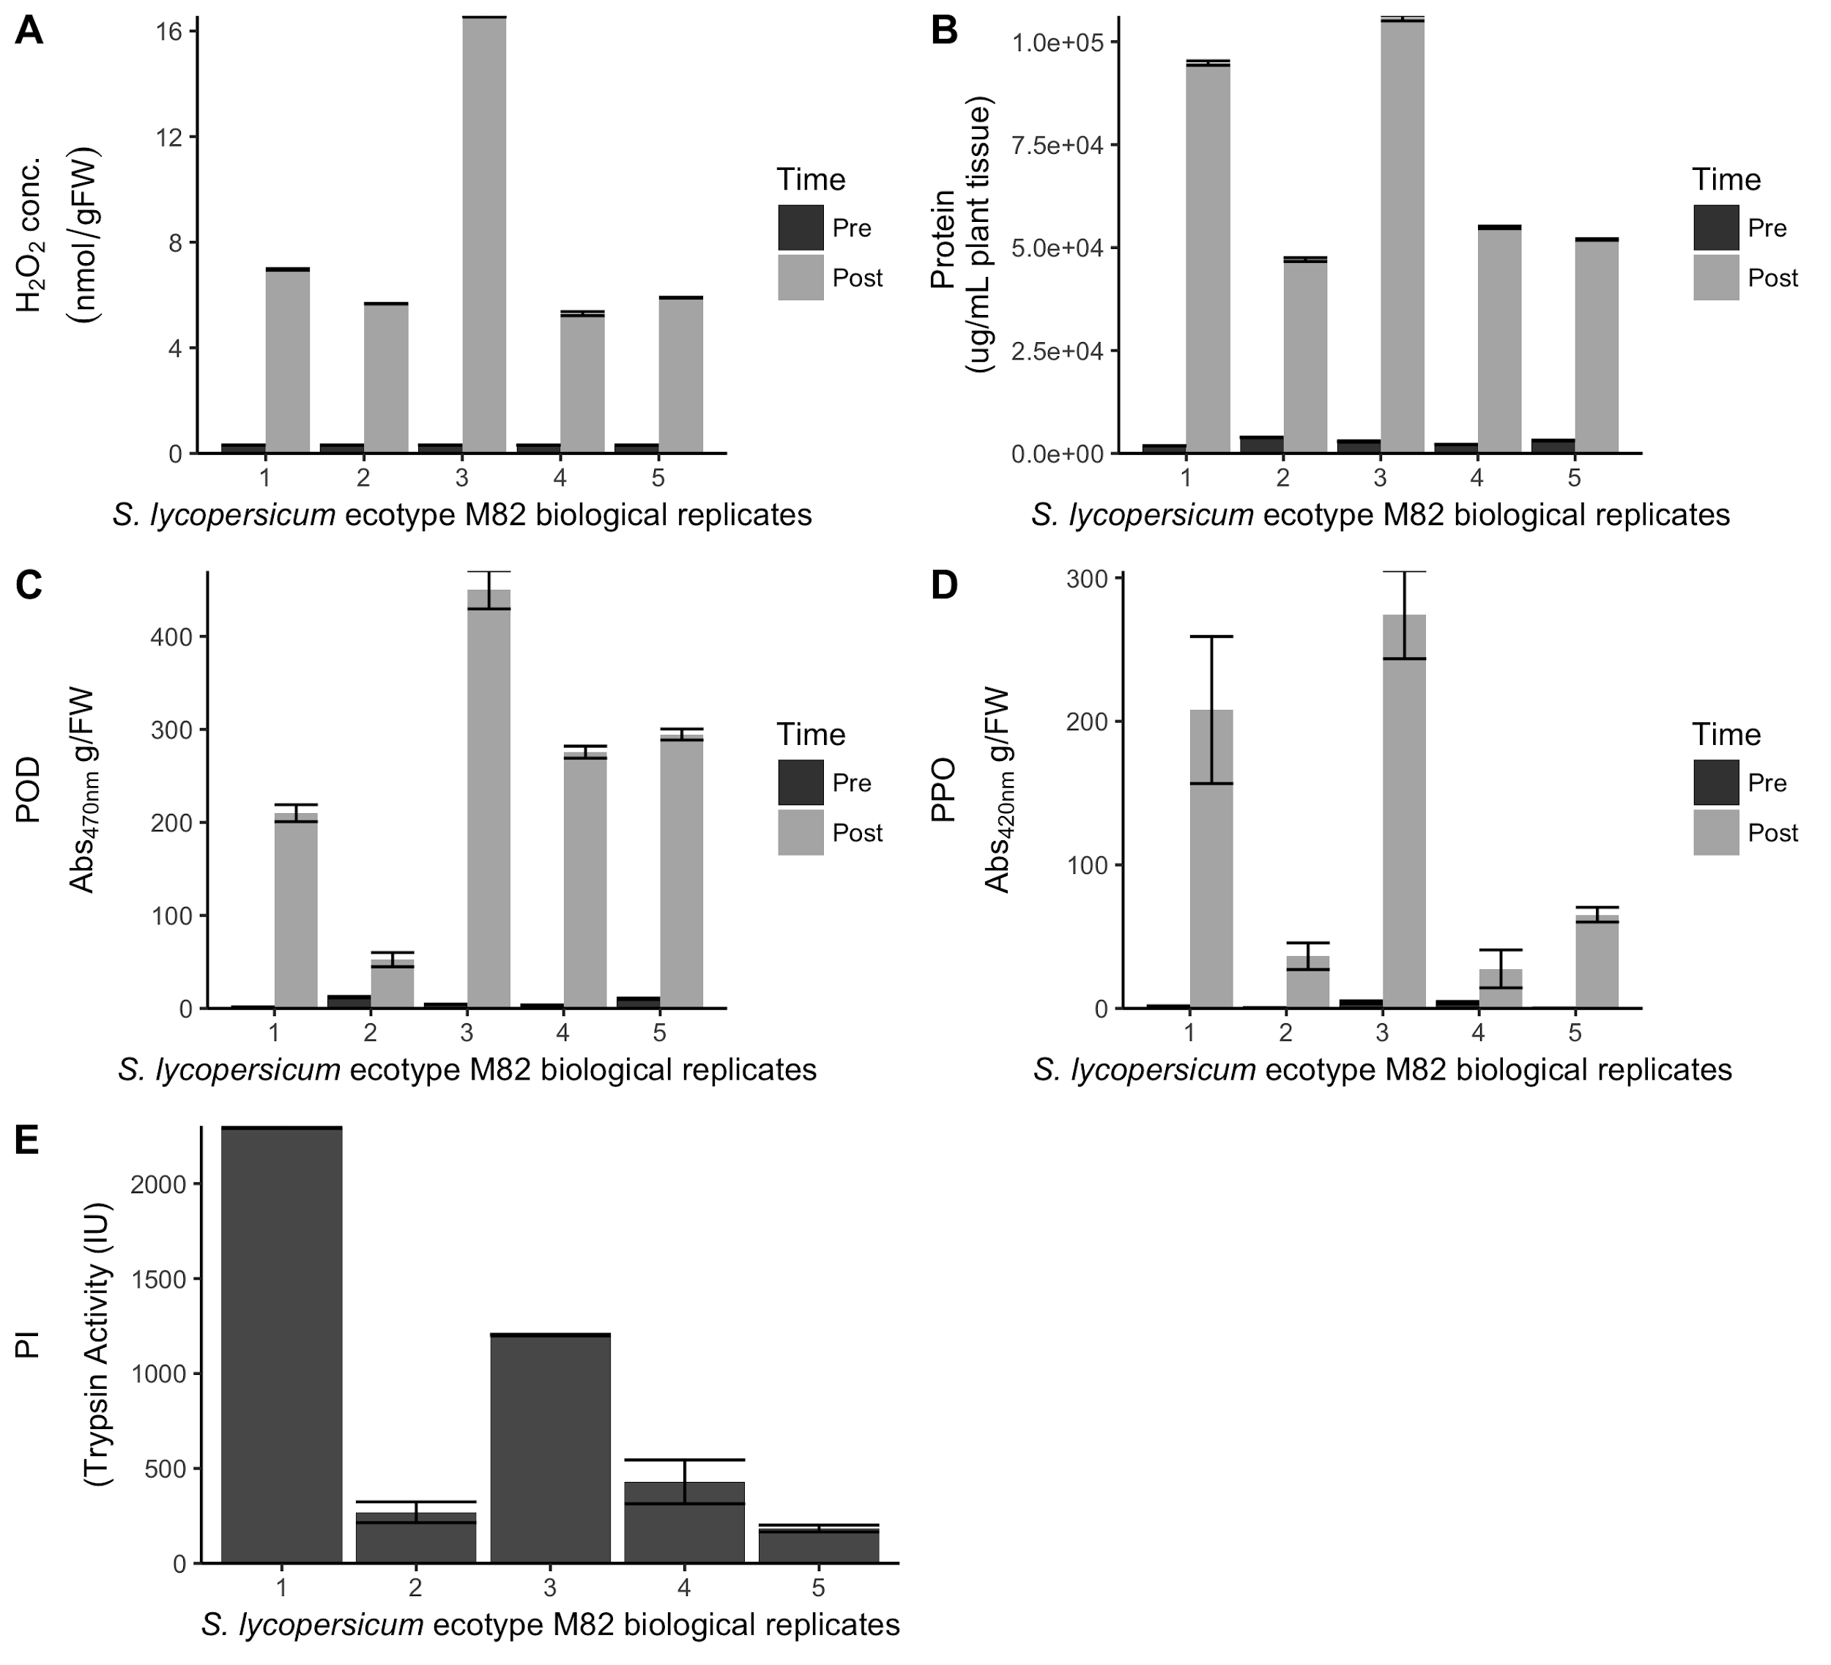

Results of our microplate-based protocols using *S. lycopersicum,* ecotype M82 for A) H2O2, B) Protein Quantification, C) POD, D) PPO, and E) PI. The numbers 1-5 on the x-axis reflect individual plants used for sampling. The significant variation between biological replicates makes a strong argument against pooling tissue samples from different plants and highlights the benefit to using a protocol that requires a much smaller quantity of tissue (see Main Document Table 1). A-D show values pre- and post-herbivory. E is calculated by subtracting post-herbivory values from pre-herbivory values. Bars in all panels show the mean with standard error bars for three biological replicates.

**Appendix 4 (will change out in word doc)**

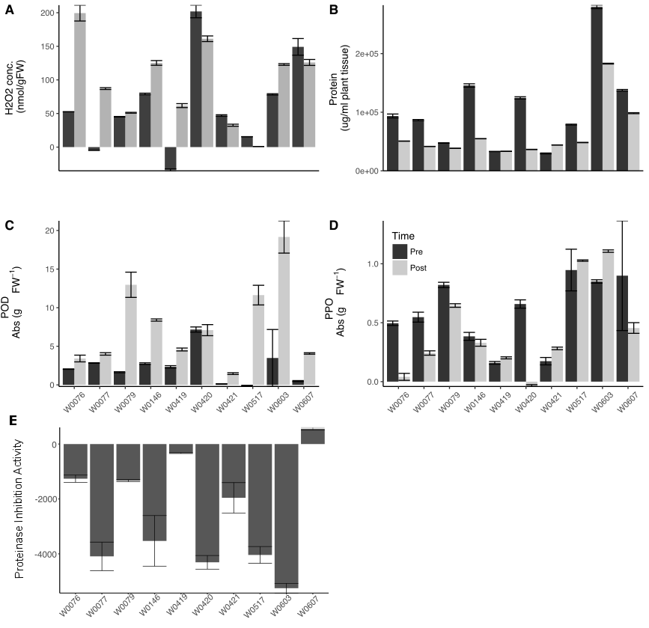

**Assays tested on *Medicago polymorpha*.** As proof of concept, we ran all of the assays on a non-model plant, *Medicago polymorpha*. A) H2O2 B) Protein Quantification C) POD D) PPO E) PI. Unlike tomato, *M. polymorpha* does not always show increase in production of defensive phytochemicals. A-D show values pre- and post-mechanical wounding with regurgitant to simulate herbivory. E is calculated by subtracting post-mechanical wounding values from pre-mechanical wounding values. Bars in all panels show the mean plus standard error bars for three biological replicates.

**Figures and legends**

Fig 1. Comparison of absorbance values for A)POD and B)PPO when measured using either a spectrophotometer (cuvette) or microplate reader (mtp) to generate a standard curve using horseradish peroxidase for POD (measured at 470 nm) and mushroom polyphenol oxidase for PPO (measured at 420 nm). Line equations and r2 values were generated by fitting data using a linear model. Each data point represents mean plus/minus standard error. All concentrations were done in triplicate.

Fig 2. Serial dilutions of uninduced tomato tissue. We serially diluted a homogenized tissue sample initially at a concentration of 0.38 g FW/mL to determine the lower limit of detection for the A) POD and B) PPO assays. We used uninduced tissue with low expression of defense compounds and measured absorbance at 470 nm for POD and 420 nm for PPO. Each dilution was measured in triplicate; data points shown are means plus/minus standard errors.